Assignment-11.5:

Embedd your pig scripts inside a java program by following the steps in the below blog. https://acadgild.com/blog/embedding-pig-java/

Input File:

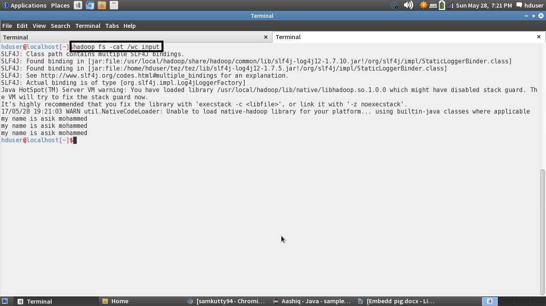

Java Program:

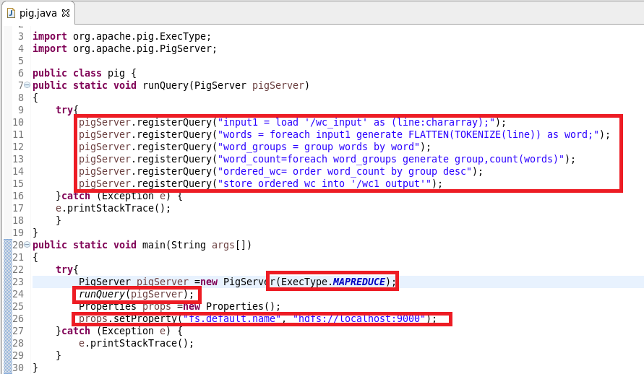

Adding Dependencies in the pom.xml:

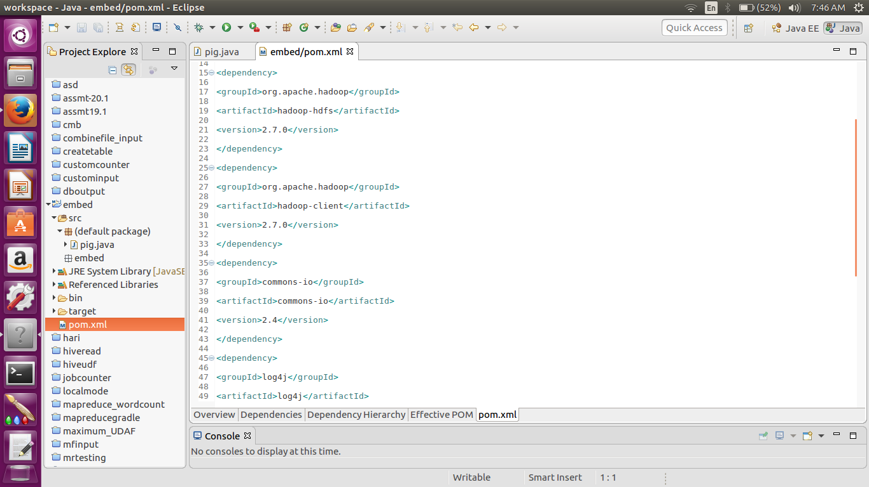

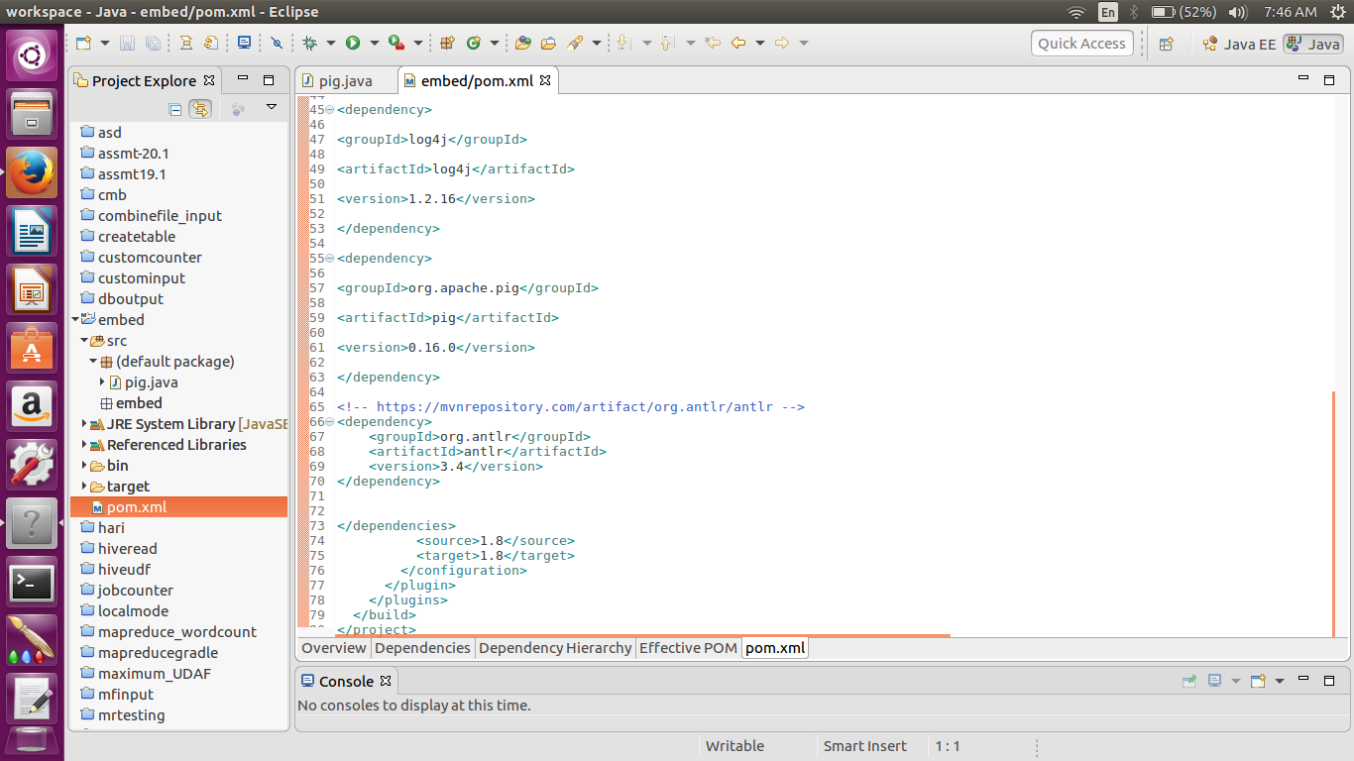

Console:

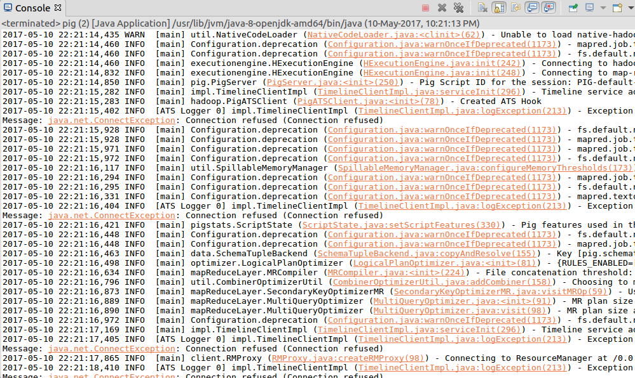

Output Stored:

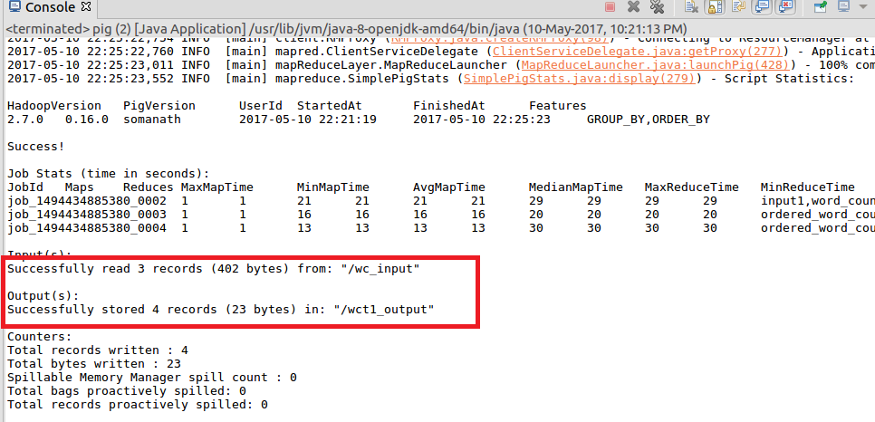

Output in HDFS:

